FEATURES OF PROJECT

HOSPITAL MANAGEMENT

1)During this pandemic time, the need of hospitals and hospitals services is of utmost priority.

Thus we have created Graphical application for Creating and storing patient appointment at ease.

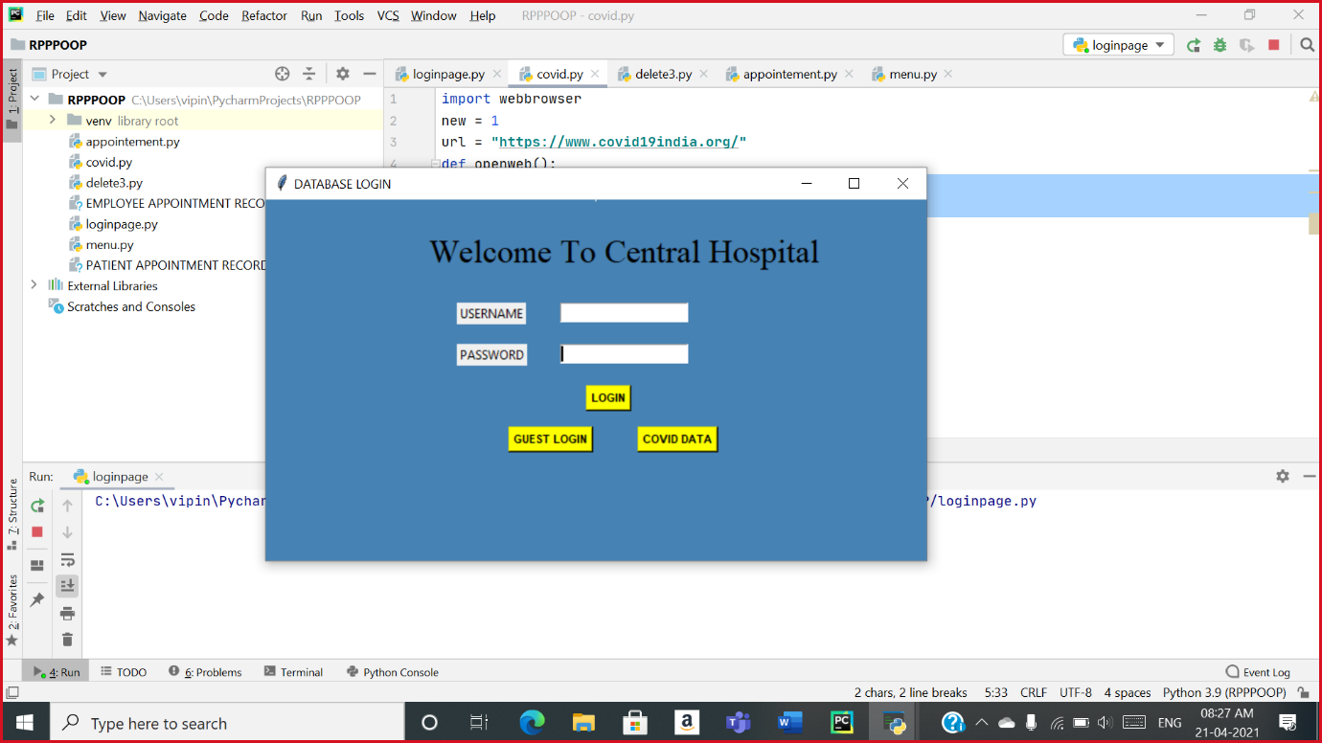

2)We in our project focuses on the registration of the patients in our hospitals and we have provided them explicit GUEST LOGIN.

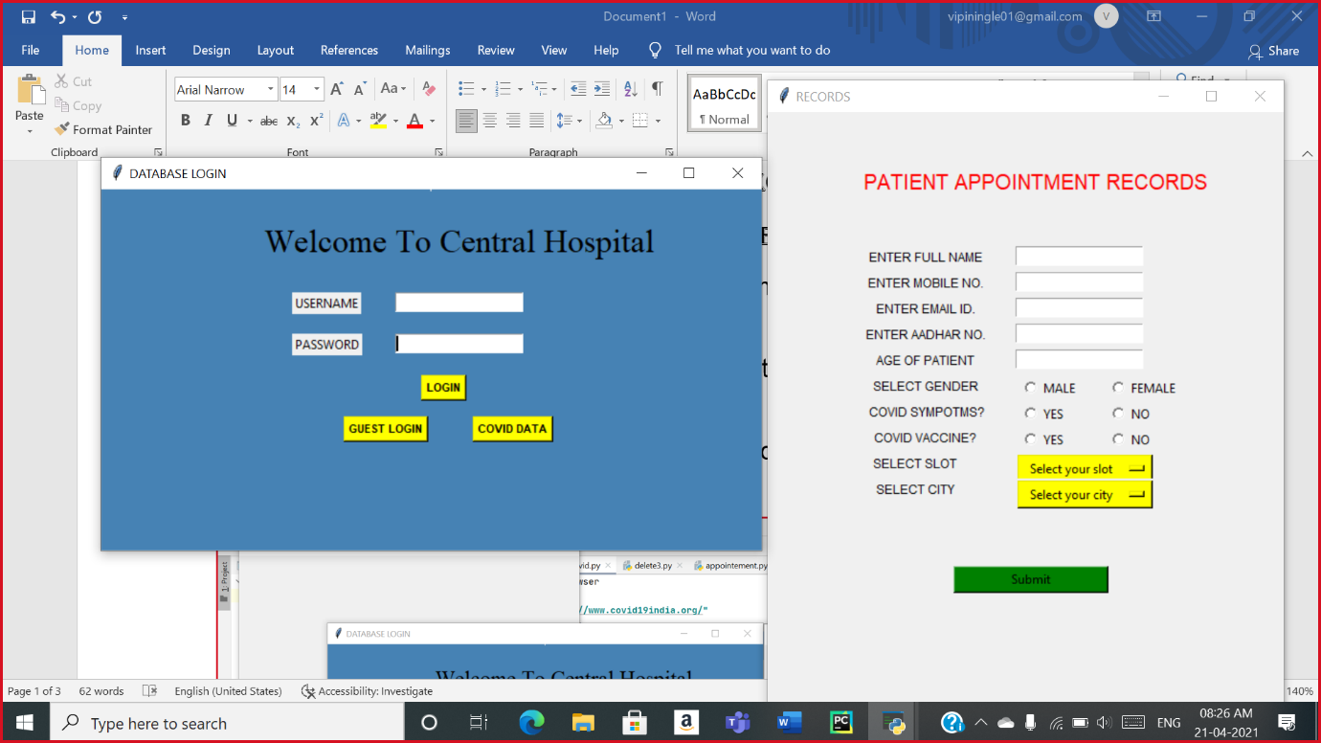

3)In our GUI, we gave option to log-in to Hospital staff so they can have more accessable feature than others.

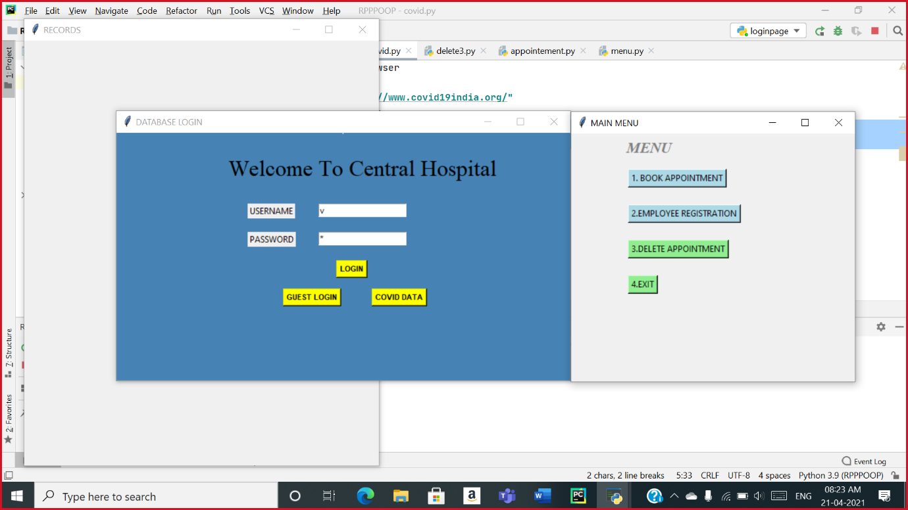

4)Management-System admins can also book appointments and can also register new employees and can delete the cancelled appointments.